PUBLIC ACCESS SPECIFIER

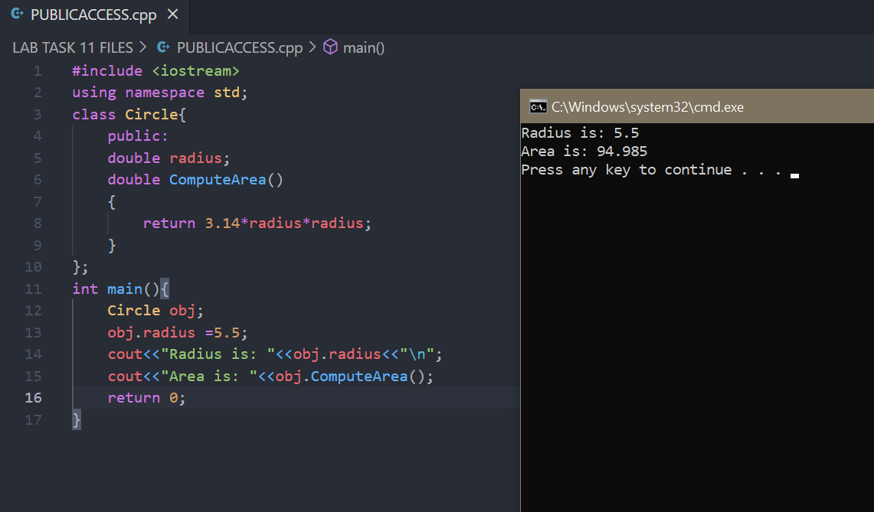

PRIVATE ACCESS MODIFER

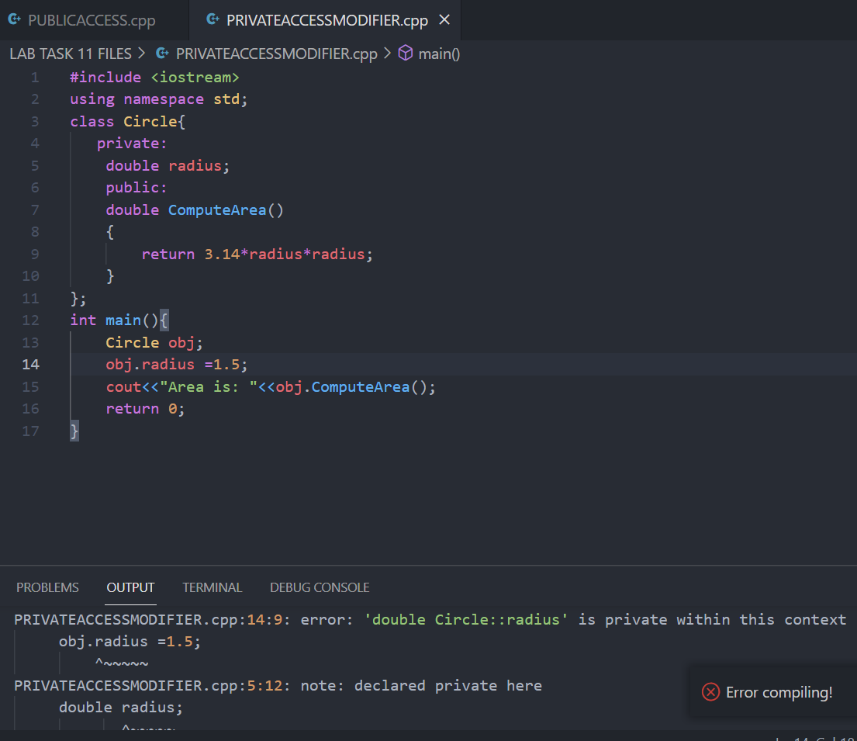

PRIVATE ACCESS SPECIFIER

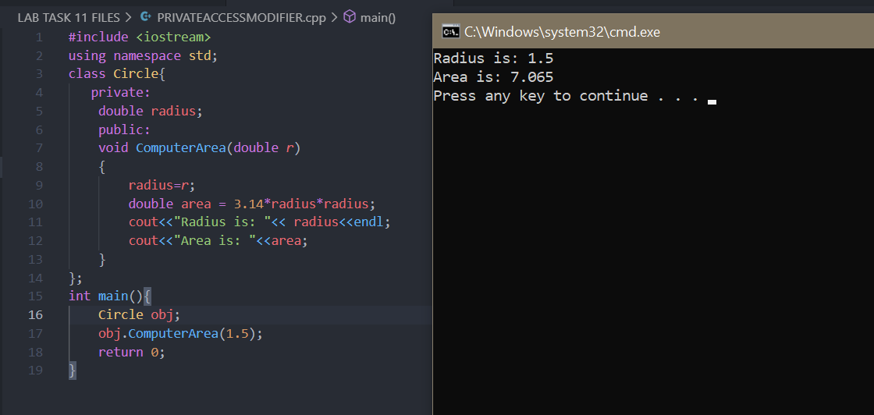

PROTECTED ACCESS SPECIFIER

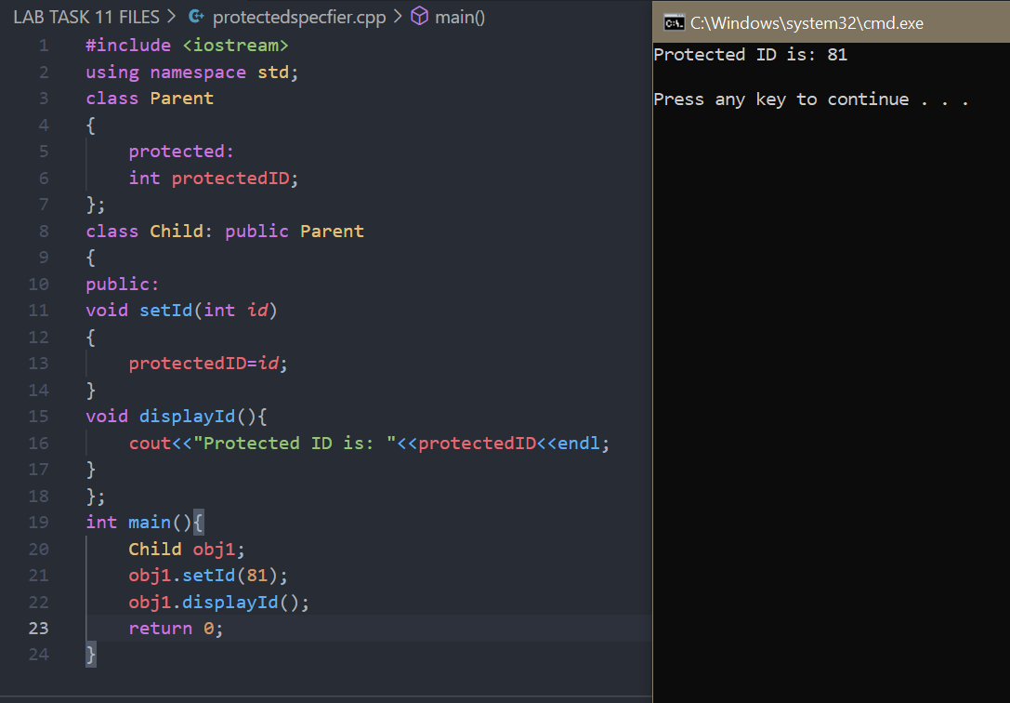

DEFAULT CONSTRUCTOR

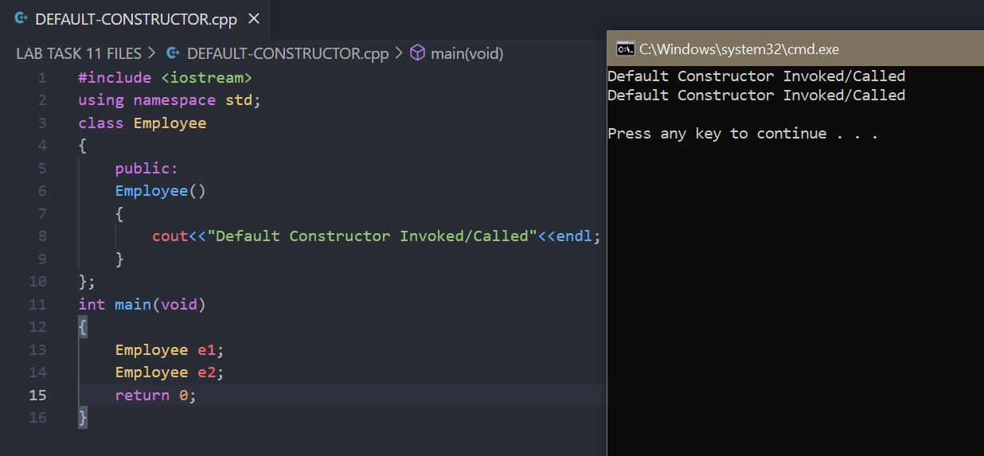

DEFAULT CONSTRUCTOR..

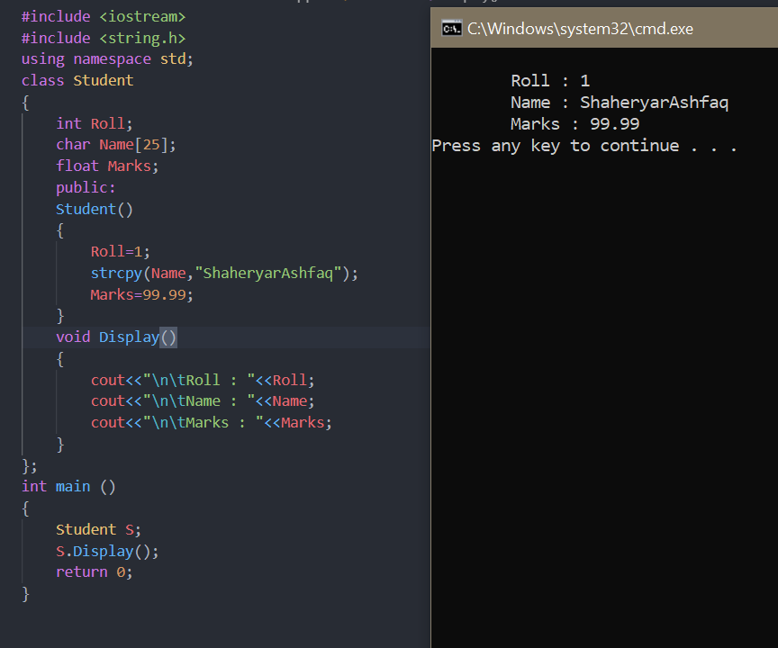

PARAMETERIZED CONSTRUCTOR

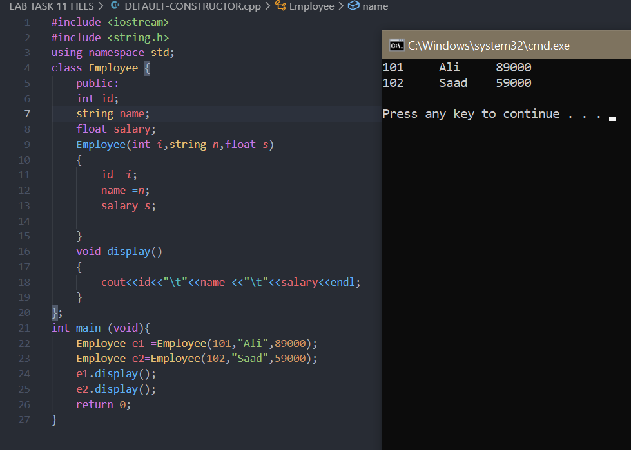

PARAMERTIZED CONSTRUCTOR 2

